## **Using Cross Entropy With Sigmoid Neuron**

What does the cross entropy loss function look like

1. Consider an example in the scope of our final project
2. Look at the following signboard 
3. $x = image, y=[0,1]$ (True distribution, where 1 corresponds to Text)
$ŷ = \frac{1}{1+e^{(-(w.x + b))}}$

4. This corresponds to $ŷ$ =0.7 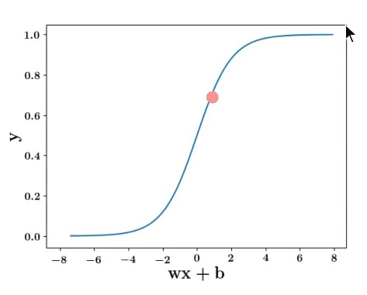
5. Thus, the predicted distribution is $ỹ=[0.3, 0.7]$ (where 0.7 corresponds to Text)
6. The Loss function is $L(θ) = -Σ_{i}y_{i}logỹ_{i}$ where $i∈\{0,1\}$
$L(θ) = -({(y}_{o_{}}log{ ỹ}_{o}) + (y_{1}log ỹ_{1}))$

7. $L(θ) = -({(y}_{o_{}}log{ (1-ỹ}_{1})) + (y_{1}log ỹ_{1}))$ (from probability axioms, y0 = 1 - y1)
8. Consider two examples side by side

|  |  |  |  |
| --- | --- | --- | --- |
| Training Data | Image | $L(θ) = -({(y}_{o_{}}log{ (1-ỹ}_{1})) + (y_{1}log ))$ | Loss function |
| y = [0, 1]  ŷ = 0.7  ỹ = [0.3, 0.7]  (Text) |  | $L(θ) = -(0*log(0.3)) + (1*log (0.7)))$ $L(θ) = -log(0.7)$ | $L(θ) = -log(ŷ)$ When true output is 1 |
| y = [1, 0]  ŷ = 0.2  ỹ = [0.8, 0.2]  (No-Text) |  | $L(θ) = -(1*log(0.8)) + (0*log (0.2)))$ $L(θ) = -log(0.8)$ | $L(θ) = -log(1-ŷ)$ When true output is 0 |

1. The Loss function can be expressed as follows
   1. $L(θ) = -log(ŷ)$ if y = 1
   2. $L(θ) = -log(1-ŷ)$ if y = 0
   3. Combining them and removing the if conditions:
 $L(θ) = -[(1-y)log(1-ŷ) + ylog(ŷ)]$

     1. When y = 1, the first term becomes 0
      2. When y = 0, the second term becomes 0